Introduction to Equilibrium

Pre Lab Exercise Name:

1. Write the equation for the reaction of hydrogen and fluorine to make hydrogen fluoride.
H₂ + F₂ ⇋ 2HF
- Write the concentration equilibrium constant expression for the above reaction. Kc = $\frac{{\left[HF\right]}^{2}}{[H2][F2]}$

- If the value of Kc for the above expression is large what does that imply about the relative value of [HF] compared to [H2] and [F2]?

It would imply that the reaction is product favored showing that there is too much products [HF] and lesser reactants [H2] and [F2], hence need to decrease the amount of product and increase the amount of reactants.

- If Kc is small (less than 1) then the _reactants____ are favored.

- If Kc is large (greater than 1) then the _products__ are favored.

- If the concentration of a reactant is doubled what happens to the value of the equilibrium constant?

The value of the equilibrium constant (K) remains the same.

- If the concentration of a product is doubled what happens to the value of the equilibrium constant?

The forward rate of reaction will be doubled meaning the reaction will lead to decrease in amount of all products and the reactants will double.

- Look up Le Chatelier’s Principle for equilibria from a reliable source; restate the principle in your own words in the space below.
If a system that is at equilibrium is disturbed by external factors such as change in temperature, pressure or change in concentration of one of the components, then the system will shift the position of its equilibrium to counteract the effects of the disturbance.

Introduction to Equilibrium

Purpose

- To observe the effects of concentration and temperature changes on chemical systems initially at equilibrium.
- To correctly write equilibrium constant expressions and interpret the meaning of the equilibrium constant.
Introduction

Many reactions are reversible. That is to say that the products of a reaction can react to yield the starting materials.

A chemical reaction has reached equilibrium conditions when the forward and reverse reactions occur at the same rate, therefore relative amounts of "product" and "reactant" remain unchanged.

The ratio of the mathematical product of the concentration of products to reactants is called the equilibrium expression and it is a constant value for a reaction (at the specified temperature) known as the equilibrium constant K. The general form for the equilibrium constant expression for any reaction involving compounds A, B, C, and D:
 |  |  | Aa + bB⇋ cC + dD
given by: | K_{c} = | [C]^{c} [D]^{d}
 |  | [A] [B]

where a, b, c, and d are the coefficients of the balanced equation.

When you are heating or cooling a system it is sometimes helpful to consider heat as part of the
equation, e.g.
Endothermic reactions: | Reactants | + heat |  | ⇋ | Products
Exothermic reactions: | Reactants | ⇋ | Products |  |  | + | heat

When you warm a solution that is the same as adding heat and when you cool it you are removing heat. So for an endothermic reaction for example, warming the container is analogous to adding more of a reactant whereas cooling the container is analogous to removing one of the reactants. Heat can be added or removed without changing the temperature, as the equilibrium reaction will shift in response to the change, replacing any heat removed or absorbing any heat added.

Experimental Chemistry

Part I Irreversible Reaction

Some chemical reactions “go to completion” and are not reversible (irreversible). A precipitation reaction will demonstrate this type of reaction.

- Add 10 drops 0.2 M BaCl2 to a clean test tube. Add 15 drops 0.2 M Na2SO4.

- Record your observations:

- Apply the solubility rules to determine the products and write the balanced equation for the reaction:

- Centrifuge the mixture and transfer the supernatant to a clean test tube.

- Add 3 drops of the Na2SO4 solution; record your observations:
Observation:
A white precipitate that is insoluble in water is formed.

Write a conclusion based on the observations of step 5. Specifically, how do your observations indicate that the reaction of BaCl2 with Na2SO4 is irreversible?

The white insoluble in water precipitate formed was the product of a reaction between BaCl2 with Na₂SO₄ which is barium sulphate. Apart from barium sulphate, the reaction also creates sodium chloride which is soluble in water. This kind of reaction is called double displacement reaction which is irreversible since barium sulphate cannot be broken down further.

Explain on a molecular level why you arrived at this conclusion.

The double displacement reaction takes place due to exchange of ions between 2 substances.
BaCl₂ + Na₂SO₄ → BaSO₄ + 2NaCl
BaSO4 is insoluble in water. NaCl dissolves in water.

Equilibrium expression:
Write the concentration equilibrium expression for the reaction of the iron(III) action with the thiocyanate anion:
Kc = $\frac{[{{{\left[Fe\left(SCN\right)\right]}^{2}}^{+}}^{ }]}{{[Fe}^{+3}][{SCN}^{-}]}$
Prepare the solution:
1. Prepare a solution of the [Fe(SCN)]²⁺ ion by mixing equal volumes (approximately 2mL each) of the 0.05M iron(III) nitrate and 0.05M potassium thiocyanate solutions and dilute the mixture to about 10x the volume (~40 mL total volume).
Based on the color you observe, would you predict this reaction to have a Kc value less than one (larger concentration of starting reagents) or a Kc greater than one (larger concentration of the product; the ion complex)?
Prediction:
Kc values less than one (larger concentration of starting reagents)
Concentration of reactants:
Competing reactions to the ion-complex reaction will change the concentration of the free iron and free
thiocyanate ions that are present in solution. Changes to the free ion concentrations causes the concentration of the ion-complex to change. The following procedures explore the selective removal of one of the reactants.
2. Pour about 5 mL of your prepared [Fe (SCN)] ²⁺ solution into a test tube. Add one drop at a time of 2M NaOH. What do you observe?
A reddish precipitate is formed
Add additional drops of 2M NaOH until no further changes are observed.
Centrifuge the mixture and transfer the supernatant (liquid) to two clean test tubes (split into two aliquots).
Colorless
Colorless
Dark red
[Fe(SCN)]²⁺
(Aq)
+
Fe³⁺ (aq)
SCN⁻ (aq) ⇋
In this part of the laboratory you will be investigating the reversible formation of the [Fe(SCN)]²⁺ ion. complex forms when iron III and the thiocyanate ion are present in the same solution. The dark red color of the ion-complex is the evidence of its formation. The net ionic equation is:
Part II Ion - Complex and Reversible Equilibria:
Iron(III) thiocyanate ion complex

Write the chemical equation that supports this observation:
Colorless
Colorless
Dark red
Add one drop KSCN solution to one clear supernatant; what do you observe?

Appearance of the deep red color

Add one drop 0.05M iron (III) nitrate to the other, what do you observe?

The color of the mixture turned into lighter red color.

Based upon your observations, which ion did the hydroxide⇋ OH-, react with when added to the equilibrium reaction?

Fe³⁺ (aq) + SCN⁻ (aq) [Fe (SCN)] ²⁺ (aq)

HO⁻ (aq) + Fe³⁺ _{(aq)} Fe (OH) ₃ ₍solid precipitate)


Explain how your observations are related to the equation for the [Fe (SCN)] ²⁺ ions? Specifically, how does adding NaOH, which does not react with [Fe (SCN)] ²⁺ ions result in the loss of the red [Fe (SCN)] ²⁺ ions?

NaOH is not part of the equilibrium reaction, however, adding NaOH to the reaction precipitates Fe³⁺ ions resulting to Fe (OH)₃ from the equilibrium system. If Fe³⁺ ions are removed from the equilibrium, then the system will no longer be in equilibrium and the reaction will favor the direction that restores Fe³⁺ ions.

- Add 10 – 20 drops of dH2O to the solid from the centrifugation of the mixture from step 2. Acidify the mixture with 3-5 drops 2 M HNO3, mixing and stirring until the solid dissolves.
Write the chemical equation for this reaction.

Add three drops KSCN, record you observations:
Appearance of the deep red color

Explain on the molecular level why acidification was required before ion-complex formation could take place.
To donate hydrogen ions to water molecules in the solution , the water will then act as base by accepting the hydrogen ion hence enabling you to end up with a neutral complex that is weakly soluble in water and precipitates.

- Add 10 drops of 0.1 M AgNO3. Record your observations. Silver thiocyanate (AgSCN) is insoluble in water. Write the equation for this precipitation reaction.

Fe (SCN) ₂ (aq) + 2AgNO_{3 (aq)} = 2AgSCN(s) + Fe (NO₃)2(aq)

Explain how adding silver ions affected the concentration of [Fe (SCN)] ²⁺ ions.

Two observations will be noted, 1st, Ag+ will react with SCN to form a precipitate of AgSCN which is insoluble in water, this will decrease the concentration of SCN and will shift the equilibrium to the left. The2nd will be the fading away of the solution color as FeSCN²⁺ concentration decreases. This shows that Ag⁺ removed SCN from the equilibrium.

Part III: Temperature and Equilibrium:

Prepare a hot water bath and an ice bath. Pour about 5 ml of your prepared [Fe (SCN)] ²⁺ solution into two separate test tubes. Place one test tube in each water bath and allow the reactions to reach new states of equilibrium (8 - 10 min).

Record your observations:

Deep red color is observed.

Explain the effect of the addition or removal of heat energy on the equilibrium of the reaction:

Addition of heat energy shifts the equilibrium to the left while removal of heat energy shifts equilibrium to the right.

Should heat be listed as a product or a reactant? Is this reaction, exothermic or endothermic?

Fe³⁺ (aq) | + | SCN⁻ (aq) | ⇋ | [Fe(SCN)]²⁺(aq)
colorless |  | colorless | ⇋ | Dark red

Heat is the product, since there was generation of heat, the reaction was exothermic reaction. In exothermic reaction, Addition of heat energy shifts the equilibrium to the left while removal of heat energy shifts equilibrium to the right.

Computer Simulations of Reversible Reactions

Open the Reversible Reactions simulation created by The Univ. of Colorado using the link provided below.

Firefox or Chrome internet browsers are recommended.

https://phet.colorado.edu/sims/cheerpj/ideal-gas/latest/ideal-gas.html?simulation=reversible-reactions
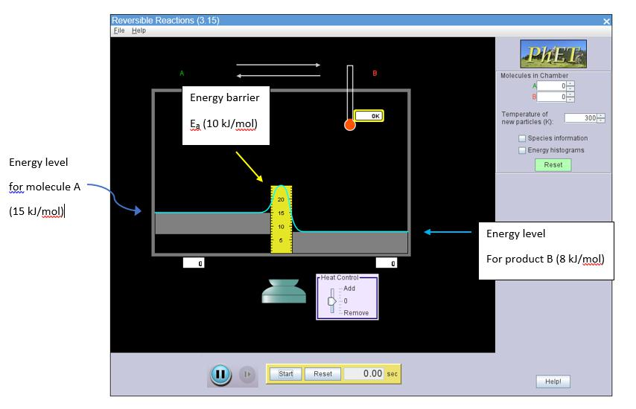

Figure 1. Reversible reactions simulator

Explore the simulation by ‘clicking and dragging’ on the various settings to see what variables can be adjusted. Note: if the energy barrier is too large, no reaction will occur; if the temperature is too low, no reaction will occur.

Add some molecules to the Reaction Chamber by typing numbers or using the increase/decrease arrow buttons.

Note: once a simulation trial is started, energy levels are not changed or adjusted during the simulation.

Consider how the ratio of green molecules to red molecules changes with time.

With reasonable energy and temperature settings, the simulation reaches a dynamic equilibrium state (DES) after enough time has elapsed. That is, a situation in which components of the system are moving and reacting in both directions, but no net change is observed.
Part IV: Exothermic Reversible Reaction

- Follow the instructions below and answer the questions:

  - Refresh the page in your browser ( ) for the simulation to adopt its initial settings. (Potential energy of A = 15 kJ/mol and pot. energy of B = 8 kJ/mol. Activation energy barrier (forward) is 10 (25-10 kJ/mol, yellow scale) as depicted in Figure 1.

The reaction is Exothermic, ∆H _{reaction} = −7 kJ / mol

  - Set the temperature of new particles to 500 K.

  - Add 100 molecules of “A” (starting molecules) and leave “B” (products) set at zero.

  - Press ‘Start’ and allow the simulation to proceed.

Questions:

- When A and B are essentially equal in number, has the reaction reached equilibrium? Circle: YES / NO
NO
- What is the ratio of B to A when the system reaches Equilibrium?
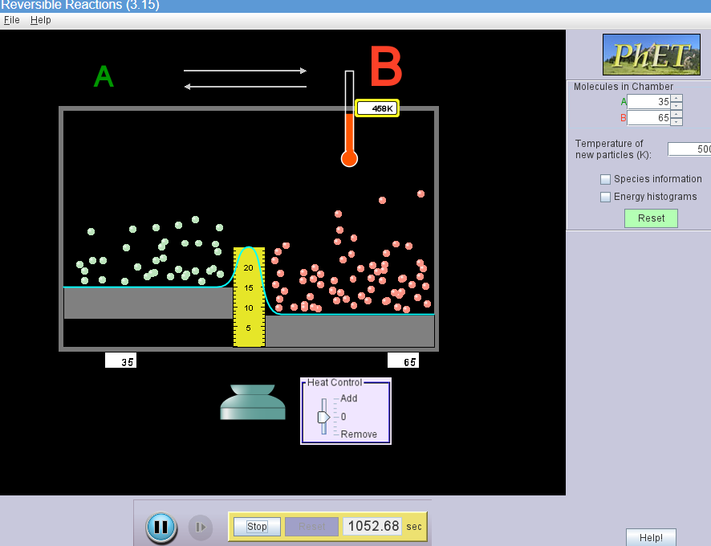

The ratio is 65:35
3. Write the equilibrium expression for the Reaction: A ⇋ B: Kc =$\frac{B}{A}$

4. Calculate the value of Kc using the numbers from your simulation.

Kc =$\frac{B}{A }$ =$\frac{65}{35}$ = 1.857

- Follow the instructions below and answer the questions:

  - Reset the simulation using the Green button.

  - Set the temperature of new particles to 500 K.

  - Add 100 molecules of B to the product side.

  - Press Start and allow the simulation to proceed.

Question:

- What is the ratio of B to A when the system reaches Equilibrium? How does this compare to the ratio in question 3 above?

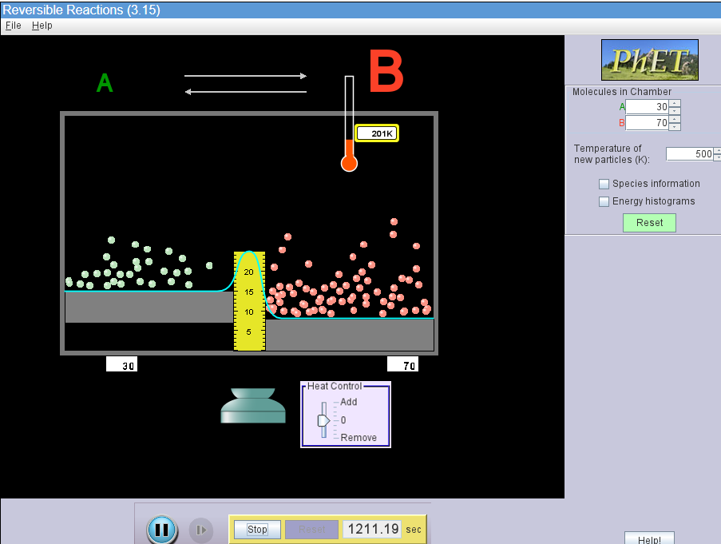

The ratio is 70:30

The ratio is higher as compared to the ratio in question 3.

- Follow the instructions below and answer the questions:

  - Reset the simulation using the Green button.

  - Set the temperature of new particles to 500 K.

  - Add any number of particles greater than 200 to either side.

  - Press Start and allow the simulation to proceed.

Question:

- Based on your results, does the equilibrium constant change as the initial numbers of reactant or product are changed, or is it independent of the initial numbers of reactant and product, and remain constant?

The equilibrium constant changes as the initial numbers of reactant or product are change and the change occurs at a slower rate. When Kc increases with a decreases in temperature, the reaction to shifts to the right. And when Kc decreases with an increase in temperature, the reaction shifts to the left

Part V: Endothermic Reversible Reaction

- Follow the instructions below and answer the questions:

  - Reset the simulation using the green button.

  - Switch the energy levels of A and B. Lower A to 8 KJ/mol and raise B to 15 KJ/mol. The reaction is now ENDOTHEMIC, ∆H _{reaction} = +7 kJ / mol
  - Set the temperature of new particles to 500 K.

  - Add 100 A molecules.

  - Press Start and allow the simulation to proceed. Keep it running for Part VI.
Questions:
- Which side of the reaction has more molecules when equilibrium is reached? Why?
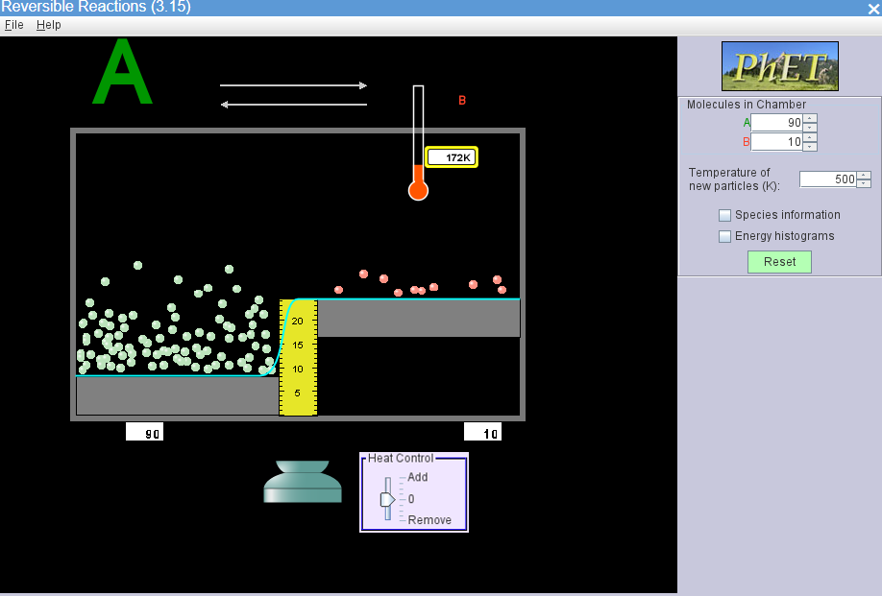
Side A has more molecules when equilibrium is reached because this being an endothermic reaction, energy was being absorbed or rather consumed. The resulting kinetic energy was not strong enough to cross the molecules in side A to side B.

- What is the ratio of B to A when the system reaches Equilibrium? How does this compare to the ratio in exothermic simulation?
The ratio is 1:9.
The ratio of endothermic reaction is lesser than the ratio of exothermic reaction. In endothermic reaction, the energy is being absorbed by the system meaning reactants will be favored. However in exothermic reaction, heat energy is being released hence reactants will absorb enough energy for conversion meaning products will be favored.

- Calculate the value of the equilibrium constant, Kc.

Kc = $\frac{B}{A }$ =$\frac{1}{9}$ = 0.11

- For the simple reversible reaction, A B, there will be (more, less) of the lower energy molecules, and (more, less) of the higher energy molecules, and Kc will be (less than, greater than) 1 for exothermic reactions, and, for an endothermic reaction, Kc will be (less than, greater than) 1.

- Does the reaction ever stop? Explain your answer to demonstrate your new understanding of equilibrium.

The reaction never stops. When a system is at equilibrium, it means that there is no further change in concentration of reactants and products but the reaction never stops. Forward and reverse reactions will not stop, they will continue at the same rate given that the reaction conditions are kept constant

Part VI. LeChatelier’s Principle

A. Addition of molecules

- Go back to the simulation which should be at equilibrium, and without resetting it, or changing any of the parameters, add at least 25 more a molecules to the system.
- Observe what happens as you add the molecules of A.

Questions.

- What happens to the number of a molecules over time after initially adding more?
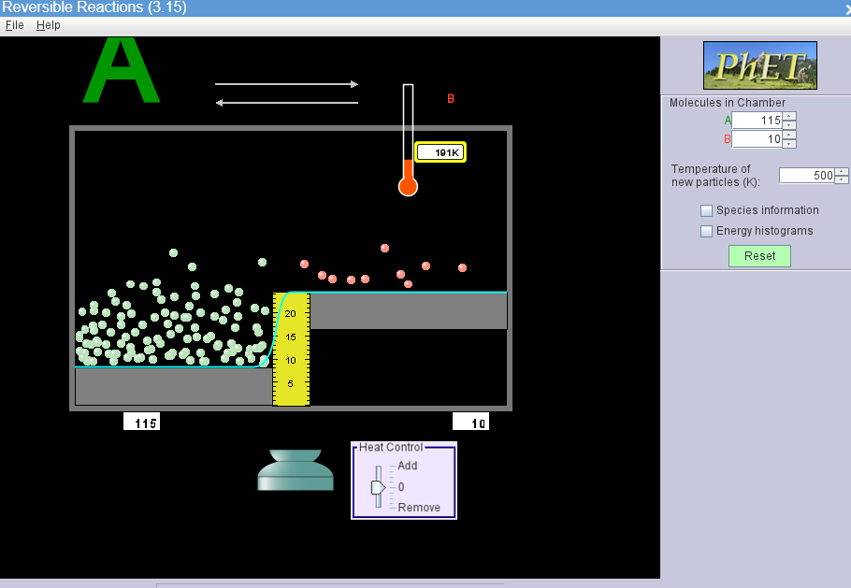

The number of molecules in side B remain constant. i.e. 10

- What happens to the number of B molecules over time after adding more A?

The number B molecules increases steadily over time as you continue adding more a molecules.

- Which direction would you say the reaction shifts upon the addition of a molecules? Towards the reactants or products?

The direction will shift to the right i.e. the reaction will start favoring the products.

- Once the system reaches Equilibrium, calculate the value of Kc. How does Kc compare to the value from question 9?

Ratio = B/A = 21/141 = 0.15
Kc has slightly increased from 0.11 to 0.15, this shows that as you add more A molecules, the reaction starts shifting to the product side but the value of Kc changes slightly.
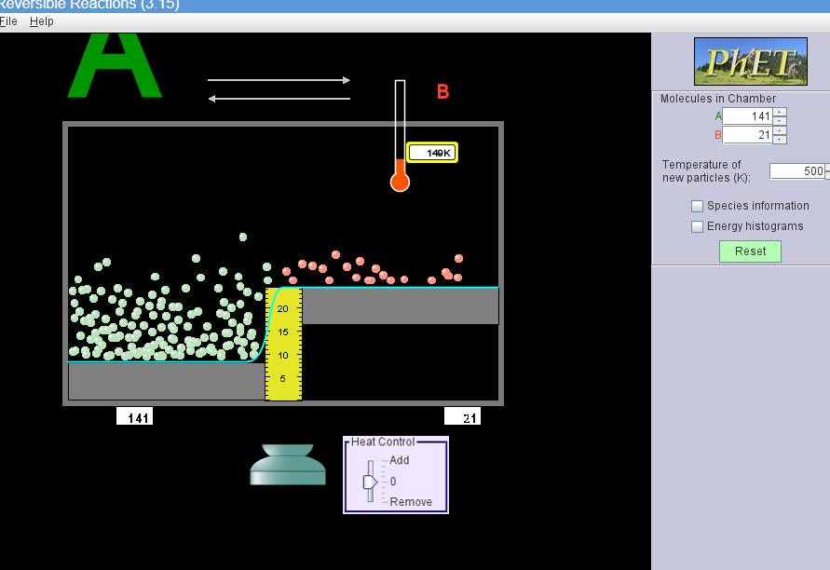

  - Removal of Molecules.

- Go back to the simulation which should be at equilibrium, and without resetting it, or changing any of the parameters, REMOVE at least 25 of the A molecules in the system.
- Observe what happens as you remove the molecules of A.
Questions.

- What happens to the number of a molecules after removing some?
The rate of their random movement reduces and the number of A molecules starts increasing.

- What happens to the number of B molecules after removing some of the A molecules?

The number of B molecules starts decreasing on removing some of the A molecules.

- Which direction would you say the reaction shifts upon the removal of A molecules? Towards the reactants or products?
The reaction will shift the equilibrium to the left, i.e. the direction will shift to the reactants.

- Once the system reaches Equilibrium, calculate the value of Kc. How does Kc compare to previous values, from questions 9 and 15?

Kc = $\frac{B}{A }$ =$\frac{9}{82}$ = 0.11

From questions 9 and 15 respectively, Kc was 0.11 and 0.15. What can be noted from here is that there is slight difference between the three. In fact it can be concluded that the value of the equilibrium constant will remain the same when the reaction is disturbed.
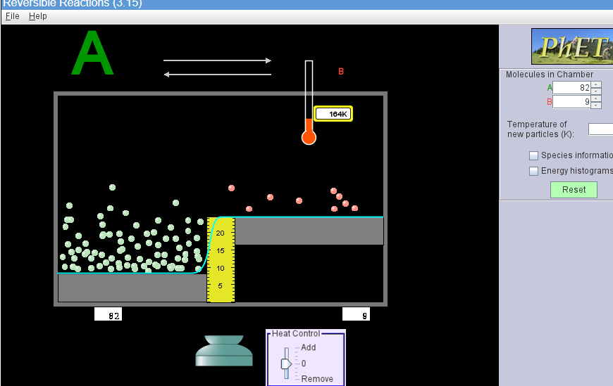

An Equilibrium reaction is one that is constantly, reacting.

By adding or removing molecules from a reaction at equilibrium, the equilibrium will be disturbed. As a result, the equilibrium reaction will shift away from the molecules that are added; the equilibrium reaction will shift towards, the molecules that are removed.

The value of the equilibrium constant will remain the same when the reaction is disturbed.

